Changes in connectivity profiles define functionally-distinct regions in human medial frontal cortex

H Johansen-Berg*¹, TEJ Behrens*¹, MD Robson², I Drobnjak¹, MFS Rushworth^{1,3}, JM Brady⁴, SM Smith¹, DJ Higham⁵and PM Matthews¹
¹Oxford Centre for Functional Magnetic Resonance Imaging of the Brain, University of Oxford, John Radcliffe Hospital, Oxford OX3 9DU, UK
²University of Oxford Centre for Clinical Magnetic Resonance Research, John Radcliffe Hospital, Oxford OX3 9DU, UK
³Department of Experimental Psychology, University of Oxford, Oxford OX1, UK
⁴Medical Vision Laboratory, Department of Engineering Science, University of Oxford, Oxford, OX1 3PJ, UK
⁵Department of Mathematics, University of Strathclyde, Glasgow, G1 1HX, Scotland, UK

*These authors contributed equally to this work

Correspondence should be addressed to H.J-B. (email: heidi@fmrib.ox.ac.uk; tel: 44 1865 222782, fax: 44 1865 222717, address: Oxford Centre for Functional Magnetic Resonance Imaging of the Brain, University of Oxford, John Radcliffe Hospital, Oxford OX3 9DU, UK)
Submission date: April 20
A fundamental issue in neuroscience is the relation between structure and function. However, gross landmarks do not correspond well to micro-structural borders and cytoarchitecture cannot be visualised in a living brain used for functional studies. Here we used diffusion-weighted and functional MRI to test structure-function relations directly. Distinct neocortical regions were defined as volumes having similar connectivity profiles and borders identified where connectivity changed. Without using prior information, we found an abrupt profile change where the border between supplementary motor area (SMA) and pre-SMA is expected. Consistent with this anatomical assignment, putative SMA and pre-SMA connected to motor and prefrontal regions, respectively. Excellent spatial correlations were found between volumes defined using connectivity alone and volumes activated during tasks designed to involve SMA or pre-SMA selectively. This demonstrates a strong relationship between structure and function in medial frontal cortex and offers a strategy for testing such correspondences elsewhere in the brain.

Since early attempts to parcellate human and non-human cortex into structurally distinct subdivisions, the hypothesis that structural borders correspond to functional borders has been widely held ^{1,2,3}. However, this hypothesis has been tested only rarely. Structural features such as sulci and gyri are commonly used to define anatomical regions in functional imaging, neurophysiology and lesion studies, yet they have only a limited correspondence to more fine-grained structural organisation such as cytoarchitecture^{4,5,6}. Micro-structural borders based, for example, on measurements of cyto-, myelo- or receptor architecture^{7,8,9}, can only be defined post mortem and the methodological demands of such studies preclude investigation of the regional functional specialisations in the same animals. Detailed testing of the relationship between these anatomically-based measures and function based on comparisons between subjects is limited by the apparently substantial inter-individual variations in microstructural anatomical boundaries^{6,5,4}.
A structural feature which has not previously been utilised to define areal boundaries in the human neocortex is connectivity to other brain regions. While features such as cytoarchitecture, myeloarchitecture and receptor distributions distinguish the processing capabilities of a region, connectional anatomy constrains the nature of the information available to a region and the influence that it can exert over other regions in a distributed network. Therefore, not only does structural variation reflect functional organisation, but local structural organisation also determines local functional specialisation. Data on brain connectivity in macaque monkeys shows that cytoarchitectonically and functionally distinct regions of prefrontal cortex have distinct connectivity ‘fingerprints’¹⁰. Differences in connectivity that parallel differences in cytoarchitecture, have been used to define subdivisions in macaque cortex within regions previously thought to be homogenous¹¹.
Previously, we have shown that the human thalamus can be subdivided using non-invasive diffusion imaging data on the basis of its connectivity to specific cortical targets¹². However, this approach was limited by the need to define potentially connected cortical target regions a priori. Here we develop a fundamentally different strategy for inferring structural parcellation from diffusion data that allows “blind” discrimination of regions with different patterns of connection. Probabilistic diffusion tractography is used to derive connectivity profiles for points along cortical regions of interest. By calculating the cross-correlation between these profiles it is possible to define regions with similar connections and to identify points where connectivity profiles change.
Our focus here is the medial frontal cortex. In the macaque monkey, the medial part of the homologue of Brodmann’s area 6 consists of two cytoarchitectonically distinct regions: F3 or SMA proper and F6 or pre-SMA^{2,13}. These two regions exhibit different functional responses^{14,15,16} and have distinct connections^{17,18}. The precise anatomical homologues of SMA and pre-SMA in humans are not clear as different studies have identified two¹⁹ or three²⁰ cytoarchitectonically distinct regions within human area 6. There is consistent evidence for a functional distinction, at least between anterior and posterior parts of human medial area 6, as functional imaging studies have found differential involvement of these regions in tasks engaging distinct cognitive or motor domains^{21,22,23}. While the arcuate sulcus corresponds with the border between SMA and pre-SMA in macaque^{16,14}, there is no local landmark that differentiates functionally-defined SMA and pre-SMA in the human brain²⁴; the vertical line from the anterior commissure (VCA line) provides the best approximation¹⁹. Here, we use novel diffusion tractography methods and fMRI to test directly whether boundaries defined by differences in connectivity can discriminate between functionally-defined SMA and pre-SMA in humans.

RESULTS
For each subject, diffusion-weighted imaging data were used to perform probabilistic tractography^{12,25} from voxels within large medial frontal cortex ‘seed’ masks. Probabilities of connection from each seed voxel to every other voxel in the brain were binarised and stored in a matrix, A, whose cross correlation matrix, B, was found. Elements in B therefore express the correlation in connectivity profile between medial frontal seed points. The nodes in B were permuted using a spectral reordering algorithm²⁶ (DJH, submitted) that forces large values towards the diagonal (see Methods). If the data contain clusters (representing seed voxels with similar connectivity), then these clusters will be apparent in the reordered matrix and break points between clusters will represent locations where connectivity patterns change. Note that if such structure is not present in the original data then the reordered matrix will not have a clustered organisation.

Connectivity-based division of medial frontal cortex
We first defined single slice orthogonal seed masks on the medial frontal cortex in the axial (MNI Z=58) or sagittal (MNI X=-2) plane on the group average T1-weighted anatomical MR image (Figure 1). These seed masks were registered to each subject’s diffusion-weighted data for generation of connectivity matrices. Reordered connectivity cross-correlation matrices contained clearly identifiable clusters in all nine subjects (Figure 2 and Supplementary Information). Note that such structure will only be apparent in the reordered matrices if there is clustered organisation in the data. The reordered matrices were divided into two or three clusters. When these clusters were mapped back onto the brain they corresponded to discrete regions situated along the anterior-posterior axis of the medial frontal cortex (Figure 2 and Supplementary Information). The border between the most anterior and most posterior cluster was located close to the vertical line extending from the anterior commissure (VCA line, Y=0) suggesting that the regions correspond to SMA and pre-SMA. In order to test this hypothesis directly we compared subregions defined on the basis of connectivity to functional activation sites during tasks designed to involve SMA or pre-SMA selectively.
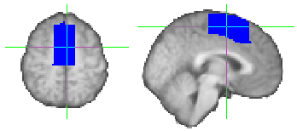
Figure 1: Medial frontal cortex mask shown in axial (left, Z=58) and sagittal (right, X=-2). The vertical line indicates the position of Y=0 (VCA line). The two slices shown are those used for the initial, single slice parcellations of medial frontal cortex.

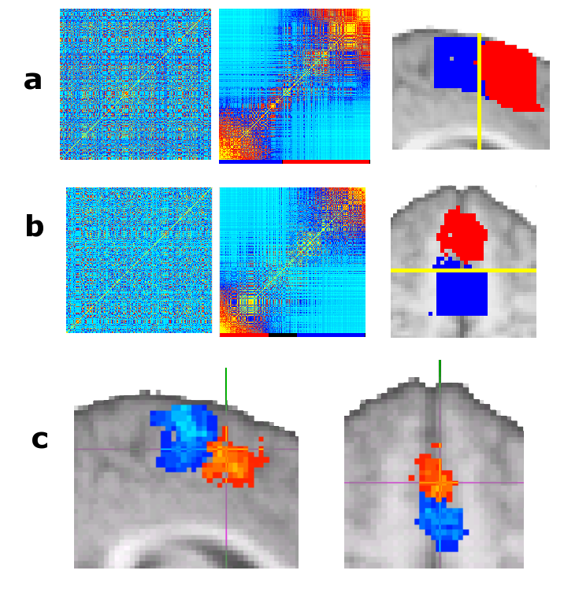

Figure 2: Connectivity-based parcellation of medial frontal cortex. A,B, Result of parcellating a sagittal (A) and axial (B) slice in a single subject. Original (left) and reordered (middle) cross-correlation matrices are shown. The clusters identified in the reordered matrices are indicated by the coloured bar underneath the matrices. Black regions on the colour bar represent matrix elements that did not clearly belong to a single cluster and were therefore unclassified. The brain images on the right show the clusters mapped back onto the brain using the same colour scheme as the colour bar. For all subjects, clusters were present in the reordered matrices and mapped onto discrete regions distributed along a posterior-anterior axis. The yellow line indicates the position of Y=0. For individual subject data from all nine subjects see Supplementary Information. C: Population probability maps for putative SMA (red to yellow) and pre-SMA (blue to turquoise) shown for single sagittal (left) and axial (right) slices. Population maps have been thresholded to only include voxels where a cluster was present in 4 or more subjects (out of 9). Green voxels represent overlap between SMA and pre-SMA. The cross hairs are positioned at Y=0 to indicate the location of the VCA line.

Medial wall activations during fMRI tasks
We acquired BOLD fMRI data while subjects performed blocks of finger tapping or serial subtraction (counting backwards in threes) alternating with rest. These two functional tasks were selected because previous studies have shown that finger tapping selectively activates the SMA²³ whereas serial subtraction activates the pre-SMA^{27,28} in the superior medial frontal cortex. Both tasks were associated with activation in the superior medial frontal cortex in all nine subjects (Figure 3A and Supplementary Information). In some subjects there was overlap between activated clusters for the two tasks. In all subjects, medial wall activations during finger tapping were more posterior and superior than those during serial subtraction, as anticipated if activation during finger tapping involves the SMA and that during serial subtraction involves the pre-SMA.
Testing structure-function correspondence
Medial superior frontal voxels activated in either fMRI task were entered into a connectivity analysis for each individual subject. For all subjects, the resulting reordered cross-correlation matrices contained clusters of similar connectivity that were defined by an investigator blind to the fMRI results (Figure 3B). In all nine subjects two connectivity clusters were identified and in 2/9 subjects an additional, smaller cluster was found between the other two (see Supplementary Information). When the clusters were mapped back onto the brain they appeared as distinct regions along the medial frontal cortex and the anterior and posterior connectivity clusters corresponded closely to the activated SMA and pre-SMA volumes during fMRI (Figure 3A,C and Supplementary Information).
The centres of gravity for superior medial frontal counting-related activations (pre-SMA) co-localised with the centres of the most anterior connectivity-defined clusters whereas the centres of movement-related activations (SMA) co-localised with the most posterior connectivity-defined clusters (Figure 4). For all subjects, the centre of the most posterior connectivity cluster was closer to functionally-defined SMA (median distance=2.23mm, range=0.42 to 5.30) compared to pre-SMA (median distance=8.02mm, range=4.53 to 13.29) (p=0.002) whereas for all subjects the centre of the anterior connectivity cluster was closer to functionally-defined pre-SMA (median distance=3.07mm, range=1.5 to 5.42) than SMA (median distance=9.13mm, range=3.47 to 13.17) (p=0.002). 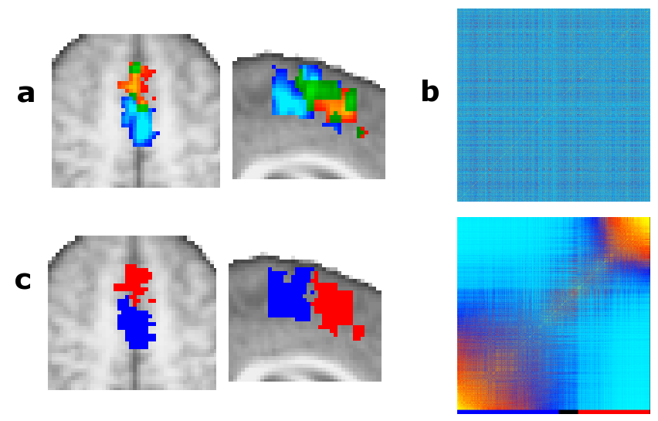
Figure 3: Testing structure-function correspondence: A: Activation for a single subject during serial subtraction (shown in red to yellow) and finger tapping (shown in blue to turquoise). Voxels activated during both tasks are coloured green. B: Original (top) and reordered (bottom) connectivity cross-correlation matrix for all medial frontal voxels that were activated in either task for this subject. The reordered matrix was divided into two clusters (indicated by coloured bar underneath matrix). C: When mapped back onto the brain, the border between the connectivity-defined clusters corresponds closely to the boundary between the functionally activated volumes. Note that although clusters are shown for example slices in A and C, the matrices in B include all voxels from the 3D volume that was activated by either task and fell within the anatomically defined medial frontal mask. The matrices in this case are therefore typically much larger than the single slice matrices shown in figure 2. Data shown is from a single individual. For data from all subjects see Supplementary Information.

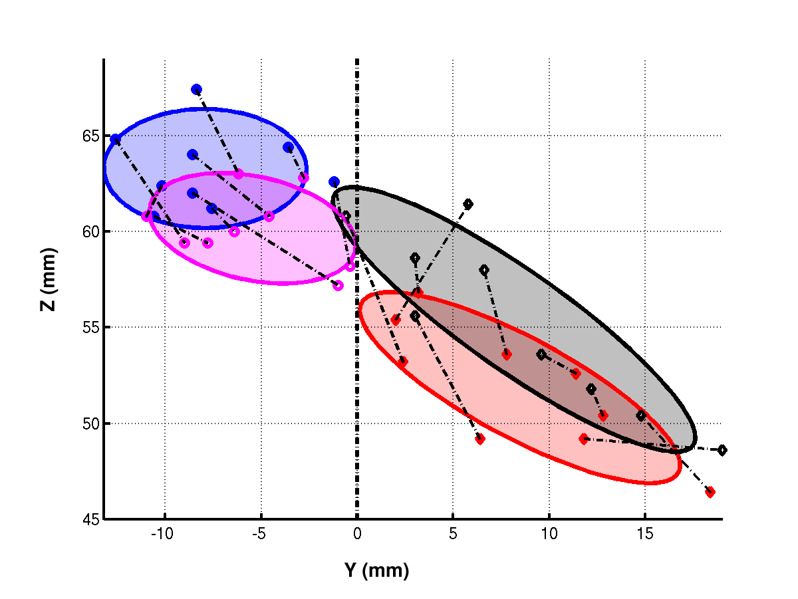
Figure 4: Co-localisation of structurally and functionally defined clusters for all subjects. Each point represents the centre of gravity of an FMRI activation or connectivity-defined cluster for a single subject. Centres of activation during finger tapping (magenta) co-localise with connectivity-defined putative SMA (blue). Whereas centres of activation during serial subtraction (black) co-localise with centres of connectivity-defined putative pre-SMA (red). Ellipses represent 85% confidence intervals. Filled symbols represent connectivity-defined points whereas open symbols represent FMRI defined points. Dashed lines connect points from the same individual.

Connections from connectivity-defined SMA and pre-SMA regions
The finding that regions corresponding to SMA and pre-SMA form distinct clusters in the reordered connectivity cross-correlation matrices reflects their different connectivity profiles. In order to explore what characterises the connectivity profile of each area, we mapped the connectivity distributions from all voxels within putative SMA or pre-SMA for each subject onto the average T1-weighted brain template. These distributions were then averaged across all subjects (Figure 5). As predicted from literature from non-human primates^{17,18,29,30,31,32,33}, connections from SMA were found to the corticospinal tract, the precentral gyrus and the ventrolateral thalamus (Figure 5A,C), whereas connections from pre-SMA were found to the superior frontal gyrus, medial parietal cortex, inferior frontal cortex and anterior thalamus (Figure 5B,C). More unexpectedly, connections were seen from SMA to orbitofrontal cortex (data not shown) and from pre-SMA to the external capsule/insula (Figure 5C). Although there is evidence for a weak orbitofrontal connection from SMA in macaque³⁴, consistent with their presence here in humans, it also is possible that the orbitofrontal and insula connections originated from superior parts of the cingulate sulcus^{31,35} included in the medial frontal seed mask. The borders between SMA/pre-SMA and the cingulate motor areas are difficult to define and the anatomy of this region is highly variable between subjects^{9,36}. The inferior border of our medial frontal mask was located a short distance above the cingulate sulcus on the group average anatomical image, corresponding to Z=50 at its most caudal end, Z=46 at the level of the VCA line and Z=38 at its most rostral end. The connection from SMA to orbitofrontal cortex was more commonly seen in subjects in whom putative SMA extended below the level of Z=48. Similarly, the connection from pre-SMA to external capsule/insula was most commonly seen in subjects in whom pre-SMA extended below the level of Z=40.
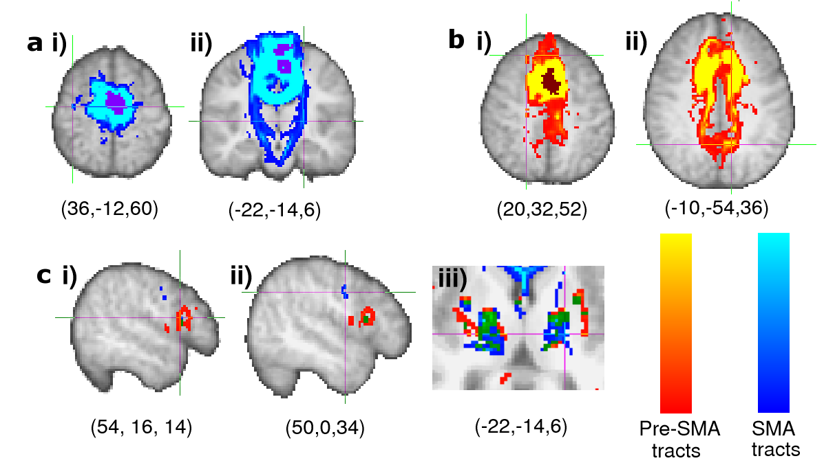

Figure 5: Connections from putative SMA and pre-SMA. A: The population map of putative SMA (thresholded at >4 subjects) is shown in purple. The group connectivity distribution is shown in blue to turquoise. Connections from putative SMA tended to go to the precentral gyrus (cross hairs in A(i) and the corticospinal tract (A(ii)). B: The population map for putative pre-SMA (>4 subjects) is shown in brown. The group connectivity distribution from putative pre-SMA is shown in red to yellow. Connections from pre-SMA tended to go to the prefrontal cortex (cross hairs in Bi show a termination point in the superior frontal gyrus) and medial parietal cortex (B(ii)). C: Group connectivity distributions from pre-SMA and SMA are rendered together for comparison; i,ii) Connections from pre-SMA terminated in inferior frontal gyrus. In the precentral gyrus, connections from SMA terminated in caudal parts of the gyrus, corresponding to motor and premotor cortices, whereas pre-SMA connections terminated in more rostral, inferior parts of precentral gyrus; iii) In the thalamus, connections from SMA travelled through the ventrolateral part of the thalamus and the adjacent internal capsule while those from pre-SMA travelled through more anterior parts of the thalamus. Green regions in C represent overlap between connectivity distributions from SMA and pre-SMA. Co-ordinates given below each brain slice indicate the location of the cross-hairs in MNI co-ordinates.

DISCUSSION
Using a generalisable method for discriminating between grey matter regions based on differences in connectivity, we identified a sharp change in connectivity profile along the superior medial frontal cortex. The specific connectivity of the more posterior region to motor and premotor cortex and the corticospinal tract and of the more anterior region to the inferior frontal gyrus, medial parietal and superior frontal cortex suggested anatomical homology to SMA and pre-SMA in the macaque brain^{17,29,30,18,31,32}. There was an excellent correspondence between these regions defined by connectivity and those identified as SMA or pre-SMA by functional criteria. These results therefore directly establish a close relationship between connectional anatomy and function in the superior medial frontal cortex and add further support to the general principle that variations in connectivity reflect functional specialisation¹⁰.
The strategy we present here provides a novel approach to in vivo investigation of human brain organisation. Previously, the only structural boundaries easily measurable in vivo were features such as gyri and sulci that do not correspond well to micro-structural borders^{6,4}. Conventionally-defined micro-structural borders based on measures such as cyto-, myelo- and receptor architecture can only be assessed post mortem. Although recent high-resolution MR imaging studies have shown some promise for detection of prominent myelo-architectonic boundaries in specific regions of visual cortex^{37,38}, it is not clear whether the approach will be more generally useful in regions with less distinct differences in myeloarchitecture. However, changes in connectivity characterise differences between many different brain regions^{10,11,17} and could therefore provide a basis for defining micro-structural boundaries much more generally.
Diffusion imaging data previously has been used to parcellate subcortical grey matter on the basis of remote connectivity¹² or local diffusion properties³⁹. For example, classification of thalamic voxels according to the cortical target with which they showed the highest probability of connection resulted in clusters that we proposed correspond to thalamic nuclei or nuclear groups^{12,40}. The approach presented here represents a fundamentally different strategy for using connectivity information to parcellate grey matter. First, it does not rely on prior knowledge of what constitute meaningful divisions in connectivity targets. The regions in the medial frontal cortex were detected using changes in connectivity profiles alone without the need for prior knowledge of what those profiles are. Having detected a change in connectivity, we were able in this case to trace the connections of the two defined regions to their major targets in order to characterise the different spatial distributions of connectivity profiles. This allowed the areas to be related to homologous regions in the macaque brain. However, accurate and complete tracing to all final targets is not essential simply for discrimination of connectionally distinct regions. This is particularly important when tracing distributions from regions of cerebral cortex where low starting anisotropy and the presence of fibre crossing and complexity can make longer distance tractography difficult.
The ability to assess borders of connectivity-defined cortical regions non-invasively allows for the individual variation and basis of brain structure to be addressed in a novel way. It already is know that there is substantial variability in both structural^{36,4,6} and functional^{41,42} brain anatomy between individuals, but a more complete description demands analysis of substantially greater numbers of individuals than can be studied conveniently using classical histological methods post mortem. However, there are limits to the information that can be provided by diffusion tractography not only due to limitations in current technology such as the difficulty of tracking in the presence of complex fibre architecture^{43,44}, but also due to fundamental limitations of diffusion imaging data. For example, it is not possible to differentiate between anterograde and retrograde connections or to determine whether a connection is direct or indirect. Therefore, classical approaches to identifying connections and defining histology remain crucially important for gaining a full understanding of cortical anatomy.
Clusters in the reordered connectivity matrices were identified by eye in the present study. In the case of connectivity data from the superior medial frontal cortex, matrices could be clearly divided in this way into two or three clusters after reordering (see Supplementary Information). However, it would be desirable to objectively determine both the number of clusters and the location of break points in reordered matrices. This will become increasingly important as the approach is applied to larger cortical volumes. There are a number of established techniques for data clustering, some of which have been successfully applied for example to brain data, for example to objectively define cytoarchitectonic borders in human corex⁴⁵. Future work will explore the suitability of such techniques for objectively identifying clusters in connectivity data.
Definition of connectional and functional boundaries in the same brain allows direct testing of structure-function relationships. Previous studies have extrapolated from population maps of cortical areas based on cytoarchitecture in one group of subjects to functionally-defined regions of cortex^{46,47} in another group in order to infer relations between structure and function. A general limitation of this strategy is the uncertain interpretation of group correlations arising from inter-individual variations in both the structural and functional borders. Determining whether variations in functional anatomy reflect variations in structural anatomy within an individual has previously been limited by the difficulty of measuring both structural and functional anatomy in the same subject. The potentially generalisable methods described here allow the connectional anatomy of the neocortex to be related both to gross anatomical features and to functional activation patterns within individuals and over relatively large populations.

METHODS
Data Acquisition
Diffusion-weighted data, BOLD fMRI data and a T1-weighted image were acquired in 9 healthy subjects (ages 24-35, 5 male, 4 female) on a 1.5T Siemens Sonata MR scanner with a maximum gradient strength of 40mTm⁻¹. All subjects gave informed written consent in accordance with ethical approval from the Oxford Research Ethics Committee.
Diffusion-weighted data were acquired using echo planar imaging (72x2mm thick axial slices, matrix size 128x104, field of view 256x208mm², giving a voxel size of 2x2x2mm). The diffusion weighting was isotropically distributed along 60 directions using a b-value of 1000smm⁻². For each set of diffusion-weighted data, 5 volumes with no diffusion-weighting were acquired at points throughout the acquisition. Three sets of diffusion-weighted data were acquired for subsequent averaging to improve signal to noise. The total scan time for the DWI protocol was 45 minutes.
BOLD FMRI data were acquired using echo planar imaging (20x5mm thick axial slices positioned to cover the top portion of the brain, matrix size 128x128, field of view 256x256mm², giving a voxel size of 2x2x5mm, TR=2.5s, 341 volumes, TE=45ms, flip angle=90˚). Subjects were given instructions and practice on the fMRI tasks before entering the scanner. Blocks (30 seconds duration) of rest (A) alternated with blocks of finger tapping (B) or serial subtraction (counting backward in threes) (C) in a 3.5 times repeated ABACACAB cycle. The current task was indicated by the word ‘rest’, ‘move’ or ‘count’ displayed on a projection screen at the foot of the scanner bed viewed via a mirror. During ‘move’ blocks subjects were trained to press buttons with the fingers of their right hand in a repeating 1234321 sequence at a frequency of approximately 4Hz. During ‘count’ blocks subjects were instructed to count covertly backwards in threes from a three digit reference number that was displayed on the screen for 2 seconds before the start of the counting block. To ensure task compliance, at the end of each counting block a red screen instructed subjects to report the number they had reached by pressing buttons with their index figure to indicate tens and middle finger to indicate units (e.g, if they had reached 47 they would press the index finger button 4 times and the middle finger button 7 times). The total scan time for the FMRI protocol was approximately 15 minutes.
A T1-weighted anatomical image was acquired using a FLASH sequence (TR=12ms, TE=5.65ms, flip angle =19º, with elliptical sampling of k-space, giving a voxel size of 1x1x1mm in 5:05minutes).

Diffusion-weighted image analysis
Diffusion data were corrected for eddy currents and head motion using affine registration to a reference volume⁴⁸. Data from the three acquisitions were averaged to improve signal to noise. Probability distributions on fibre direction were calculated at each voxel using previously described methods²⁵. Probabilistic tractography was then performed from voxels within specified seed masks^{12,25}.
A medial frontal cortex mask was defined on the group average T1-weighted image using fslview (http://www.fmrib.ox.ac.uk/fsl) (Figure 1). The mask included grey matter on the medial wall and extended from the level of y=-22 to y=30 (MNI co-ordinates) and from a short distance above the cingulate sulcus (as visible on the average brain) to the dorsal surface of the brain. Two single slice masks were used for initial parcellation: an axial slice (MNI Z=58) and a sagittal slice (MNI X=-2). These masks were transformed into the space of each subject’s diffusion data using FLIRT⁴⁸. For each subject, probabilistic tractography was run from all voxels in this seed mask^{12,25}. Probabilities of connection from each seed voxel (at 2x2x2mm resolution) to every other voxel in the brain (re-sampled to 5x5x5mm) were binarised and stored in a matrix, A, of dimensions (number of seed voxels x number of voxels in the rest of the brain), whose cross correlation matrix, B, was found. B is therefore a symmetric matrix of dimensions (number of seeds x number of seeds) in which the (i,j)th element value is the correlation between the connectivity profile of seed i and the connectivity profile of seed j. The nodes in B were permuted using a spectral reordering algorithm²⁶(DJH, submitted) that finds the reordering that minimises the sum of element values multiplied by the squared distance of that element from the diagonal, hence forcing large values toward the diagonal. If the data contains clusters (representing seed voxels with similar connectivity), then these clusters will be apparent in the reordered matrix and break points between clusters will represent locations where connectivity patterns change. Clusters were identified by eye as groups of elements that were strongly correlated with each other and weakly correlated with the rest of the matrix. Elements that did not clearly belong to a single cluster were left unclassified.
Population maps of resulting clusters in brain space were derived by binarising clusters corresponding to putative SMA (most posterior cluster) and pre-SMA (most anterior cluster) for each subject and averaging these binarised clusters across subjects so that voxel values in the population maps indicated the proportion of subjects in whom a cluster was present at that point.
Functional magnetic resonance image analysis
FMRI data were analysed using tools from FSL (www.fmrib.ox.ac.uk/~fsl). The following pre-processing steps were applied: motion correction using MCFLIRT; removal of non-brain structures using BET⁴⁹; spatial smoothing using a Gaussian kernel of FWHM 3mm; mean based intensity normalisation of all volumes by the same factor; temporal high pass filtering using Gaussian-weighted least squares fitting with a filter of sigma=57.5 seconds. Time series statistical analysis was carried out using FILM with local autocorrelation correction⁵⁰. Z (Gaussianised T) statistic images were thresholded using Gaussian Random Field theory-based maximum height thresholding with a corrected significance threshold of P=0.01. Registration to standard space was carried out using FLIRT⁴⁸.
Assessing structure-function correspondence
For each subject, voxels that were suprathreshold for either functional task and that were contained within the anatomically-defined medial frontal VOI were used to define a seed mask for further connectivity analyses. Cross-correlation connectivity matrices for these activated voxels were derived, reordered and mapped back onto the brain as before to define a putative SMA and pre-SMA for each subject. Centres of gravity of FMRI activation clusters and of connectivity-defined clusters were found and the distances between connectivity- and functionally-defined clusters were compared using paired t-tests. To characterise the connections of SMA and pre-SMA the connectivity distributions for all voxels within each region were found for each subject. These profiles were then averaged across subjects and mapped onto the average T1-weighted brain in standard space.

Acknowledgements
We acknowledge the generous support of the Wellcome Trust (HJB), UK Medical Research Council (HJB, PMM, MFSR, SMS, TEJB), UK Engineering and Physical Science Research Council (TEJB, SMS), the EPSRC-MRC IRC “From medical images and signals to clinical information” (JMB), The Royal Society (MFSR) and The Royal Society of Edinburgh/Scottish Executive Education and Lifelong Learning Department Research Fellowship Scheme (DJH). We are grateful to Emma Sillery, Paula Croxson, Peter Hobden and Clare Mackay for assistance with data acquisition and to David Gavaghan for advice on matrix computation.

References

1. Brodmann, K Lokalisationslehre der Grosshirnrinde in ihren Prinzipien dargestellt auf Grund des Zellenbaues. (Barth, Liepzig; 1909).
2. Vogt, O. & Vogt, C. Allgemeinere Ergebnisse unserer Hirnforschung. J Psychol Neurol 25, 277-462 (1919).
3. Campbell, A. W. Histological studies on the localisation of cerebral function. (Cambridge University Press, Cambridge; 1905).
4. Amunts, K. et al Broca's region revisited: cytoarchitecture and intersubject variability. J Comp Neurol 412, 319-341 (1999).
5. Amunts, K. et al Brodmann's areas 17 and 18 brought into stereotaxic space-where and how variable? Neuroimage. 11, 66-84 (2000).
6. Geyer, S., Schleicher, A., & Zilles, K. Areas 3a, 3b, and 1 of human primary somatosensory cortex. NeuroImage 10, 63-83 (1999).
7. Roland, P.E. & Zilles, K. Structural divisions and functional fields in the human cerebral cortex. Brain Res. Brain Res. Rev. 26, 87-105 (1998).
8. Zilles, K. & Palomero-Gallagher, N. Cyto-, myelo-, and receptor architectonics of the human parietal cortex. Neuroimage. 14, S8-20 (2001).
9. Vogt, B.A., Nimchinsky, E.A., Vogt, L.J., & Hof, P.R. Human cingulate cortex: surface features, flat maps, and cytoarchitecture. J Comp Neurol. 359, 490-506 (1995).
10. Passingham, R.E., Stephan, K.E., & Kotter, R. The anatomical basis of functional localization in the cortex. Nat. Rev. Neurosci. 3, 606-616 (2002).
11. Vogt, B.A. Structural organisation of cingulate cortex: Areas, neurons and somatodendritic transmitter receptors. 19-70 (1993).
12. Behrens, T.E.J. et al Non-invasive mapping of connections between human thalamus and cortex using diffusion imaging. Nat. Neurosci. 6, 750-757 (2003).
13. Matelli, M., Luppino, G., & Rizzolatti, G. Architecture of superior and mesial area 6 and the adjacent cingulate cortex in the macaque monkey. J Comp Neurol 311, 445-462 (1991).
14. Luppino, G. et al Multiple representations of body movements in mesial area 6 and the adjacent cingulate cortex: an intracortical microstimulation study in the macaque monkey. J. Comp Neurol. 311, 463-482 (1991).
15. Tanji, J. Sequential organization of multiple movements: involvement of cortical motor areas. Annu. Rev. Neurosci. 24, 631-651 (2001).
16. Matsuzaka, Y., Aizawa, H., & Tanji, J. A motor area rostral to the supplementary motor area (presupplementary motor area) in the monkey: neuronal activity during a learned motor task. J Neurophysiol. 68, 653-662 (1992).
17. Luppino, G., Matelli, M., Camarda, R., & Rizzolatti, G. Corticocortical connections of area F3 (SMA-proper) and area F6 (pre-SMA) in the macaque monkey. J Comp Neurol 338, 114-140 (1993).
18. Wang, Y., Shima, K., Sawamura, H., & Tanji, J. Spatial distribution of cingulate cells projecting to the primary, supplementary, and pre-supplementary motor areas: a retrograde multiple labeling study in the macaque monkey. Neurosci Res. 39, 39-49 (2001).
19. Zilles, K. et al Anatomy and transmitter receptors of the supplementary motor areas in the human and nonhuman primate brain. Adv. Neurol. 70, 29-43 (1996).
20. Vorobiev, V. et al Parcellation of human mesial area 6: cytoarchitectonic evidence for three separate areas. Eur. J Neurosci 10, 2199-2203 (1998).
21. Picard, N. & Strick, P.L. Motor areas of the medial wall: a review of their location and functional activation. Cereb. Cortex 6, 342-353 (1996).
22. Rushworth, M.F., Hadland, K.A., Paus, T., & Sipila, P.K. Role of the human medial frontal cortex in task switching: a combined fMRI and TMS study. J Neurophysiol. 87, 2577-2592 (2002).
23. Rao, S.M. et al Functional magnetic resonance imaging of complex human movements. Neurology 43, 2311-2318 (1993).
24. Geyer, S. The microstructural border between the motor and the cognitive domain in the human cerebral cortex. Adv. Anat. Embryol. Cell Biol. 174, I-89 (2004).
25. Behrens, T.E.J. et al Characterization and propagation of uncertainty in diffusion-weighted MR imaging. Magn Reson Med 50, 1077-1088 (2003).
26. Barnard, S.T., Pothen, A., & Simon, H.D. A spectral algorithm for envolope reduction of sparse matrices. Numerical Linear Algebra with Applications 2, 317-334 (1995).
27. Johansen-Berg, H. & Matthews, M. Attention to movement modulates activity in sensori-motor areas, including primary motor cortex. Exp Brain Res 142, 13-24 (2002).
28. Arthurs, O.J., Johansen-Berg, H., Matthews, P.M., & Boniface, S.J. Attention differentially modulates the coupling of fMRI BOLD and evoked potential signal amplitudes in the human somatosensory cortex. Exp Brain Res in press, (2004).
29. Matelli, M. & Luppino, G. Thalamic input to mesial and superior area 6 in the macaque monkey. J Comp Neurol. 372, 59-87 (1996).
30. Bates, J.F. & Goldman-Rakic, P.S. Prefrontal connections of medial motor areas in the rhesus monkey. J Comp Neurol 336, 211-228 (1993).
31. Morecraft, R.J. & Van Hoesen, G.W. Cingulate input to the primary and supplementary motor cortices in the rhesus monkey: evidence for somatotopy in areas 24c and 23c. J Comp Neurol 322, 471-489 (1992).
32. Sakai, S.T., Inase, M., & Tanji, J. Pallidal and cerebellar inputs to thalamocortical neurons projecting to the supplementary motor area in Macaca fuscata: a triple-labeling light microscopic study. Anat. Embryol. (Berl) 199, 9-19 (1999).
33. Cavada, C. & Goldman-Rakic, P.S. Posterior parietal cortex in rhesus monkey: II. Evidence for segregated corticocortical networks linking sensory and limbic areas with the frontal lobe. J. Comp Neurol. 287, 422-445 (1989).
34. Morecraft, R.J. & Van Hoesen, G.W. Frontal granular cortex input to the cingulate (M3), supplementary (M2) and primary (M1) motor cortices in the rhesus monkey. J Comp Neurol 337, 669-689 (1993).
35. Cavada, C. et al The anatomical connections of the macaque monkey orbitofrontal cortex. A review. Cereb. Cortex 10, 220-242 (2000).
36. Paus, T. et al Human cingulate and paracingulate sulci: pattern, variability, asymmetry, and probabilistic map. Cereb. Cortex. 6, 207-214 (1996).
37. Clark, V.P., Courchesne, E., & Grafe, M. In vivo myeloarchitectonic analysis of human striate and extrastriate cortex using magnetic resonance imaging. Cereb. Cortex 2, 417-424 (1992).
38. Walters, N.B. et al In vivo identification of human cortical areas using high-resolution MRI: an approach to cerebral structure-function correlation. Proc. Natl. Acad. Sci. U. S. A 100, 2981-2986 (2003).
39. Wiegell, M.R., Tuch, D.S., Larsson, H.B., & Wedeen, V.J. Automatic segmentation of thalamic nuclei from diffusion tensor magnetic resonance imaging. Neuroimage. 19, 391-401 (2003).
40. Johansen-Berg, H. et al Functional-anatomical validation and individual variation of diffusion tractography-based segmentation of the human thalamus. Cereb. Cortex in press, (2004).
41. Xiong, J. et al Intersubject variability in cortical activations during a complex language task. Neuroimage. 12, 326-339 (2000).
42. Hasnain, M.K., Fox, P.T., & Woldorff, M.G. Intersubject variability of functional areas in the human visual cortex. Hum. Brain Mapp. 6, 301-315 (1998).
43. Pierpaoli, C. et al Water diffusion changes in Wallerian degeneration and their dependence on white matter architecture. Neuroimage. 13, 1174-1185 (2001).
44. Mori, S. & van Zijl, P.C. Fiber tracking: principles and strategies - a technical review. NMR Biomed. 15, 468-480 (2002).
45. Schleicher, A. et al Observer-independent method for microstructural parcellation of cerebral cortex: A quantitative approach to cytoarchitectonics. Neuroimage. 9, 165-177 (1999).
46. Geyer, S. et al Two different areas within the primary motor cortex of man. Nature 382, 805-807 (1996).
47. Bodegard, A. et al Somatosensory areas in man activated by moving stimuli: cytoarchitectonic mapping and PET. Neuroreport 11, 187-191 (2000).
48. Jenkinson, M. & Smith, S. Global optimisation for robust affine registration. Medical Image Analysis 5, 143-156 (2001).
49. Smith, S.M. Fast robust automated brain extraction. Hum. Brain Mapp. 17, 143-155 (2002).
50. Woolrich, M.W., Ripley, B.D., Brady, M., & Smith, S.M. Temporal Autocorrelation in Univariate Linear Modeling of FMRI Data. NeuroImage 14, 1370-1386 (2001).

